INFORME DE ANGIOGRAFÍA CORONARIA

FECHA: __________________________________________________________________________
NOMBRE DEL PACIENTE: ___________________________________________________________
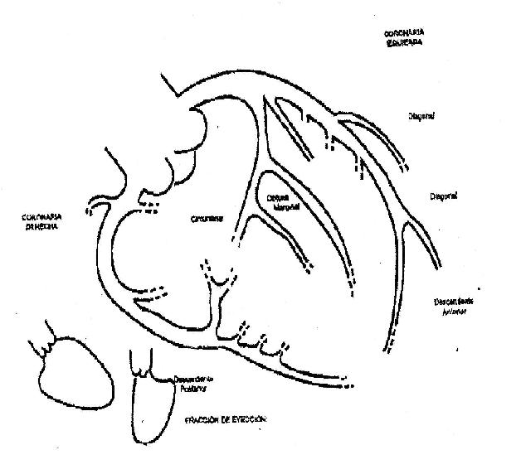
DOCUMENTO: ___________________ EPS: _______________________________________

MEDICO TRATANTE: _______________________________________________________________
OBSERVACIONES:_________________________________________________________________________________________________________________________________________________________________________________________________________________________________________________________________________________________________________________
________________________________________________________________________________

